AUDITIONS
A Northwest Premier!

What a Difference It Makes
(A Musical Drama based on the book “Teach Me, Lord, to Dance” by George W. Pettingell)

CAST NEEDED:
ADULTS – 4 Men & 4 Women
*male lead will be portraying Jesus in contemporary form*
YOUTH – 1 Boy & 1 Girl
CHORUS – Adults, Youth & Children

Please Be Prepared With A Monologue
& A Short Song To Sing (A capella)

AUDITIONS EXTENDED:
Sunday, Mar. 22 at 3 PM

AUDITIONS ALSO BY APPOINTMENT

Auditions & Rehearsals held at
PENINSULA LUTHERAN CHURCH
6509 – 38th Ave NW, Gig Harbor, 98335
(Held in the Education Building – watch for signs)

Tech & Support people also welcomed – Promotions, Props, Hospitality, Costumes, Prayer Team, etc.
*Ask us about College Internship opportunities*

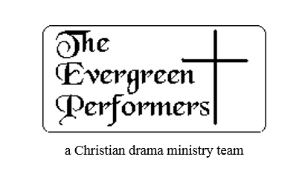 |  | Contact US FOr MORE INFo & DIRECTIONS  253-884-4628 | ev.perf@intergity.com  www.evergreenperformers.org  www.facebook.com/TheEvergreenPerformers  For directions, call 253-225-1917

THE MUSICAL WILL BE PRESENTED LOCALLY IN MAY & JUNE

